L. Kim Keesler taught junior high and high school band and choir from 1984-1994 at RHS. He started his teaching career at Cole R-V Eugene after graduating with a Bachelors of Music Education and Performance from Southwest Baptist College in 1979. While at RHS, Mr. K, as his students called him, fostered relationships with every student he came into contact with and worked to transform the music program while bestowing his love of music and teaching respect, hard work and integrity. He spent many hours at the school giving lessons and holding band practices but you could also find him running the clock at basketball games, umpiring at baseball/softball games and was even the cheerleading coach for a while.

After he retired from teaching he continued to direct various choirs, play instruments in bands and arrange music for professional performers. He loved music and it permeated his life in every area. The family of Mr. Keesler offers this scholarship in his memory to benefit a student with a love and passion for music.

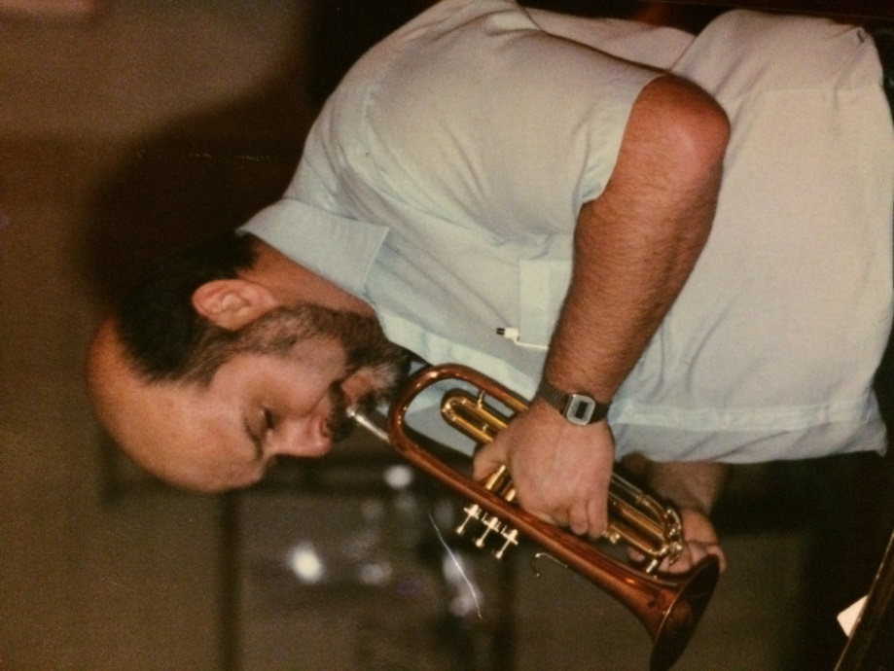

Amount - $500 awarded to 1 student.

Minimum Qualifications
- Graduating seniors with a declared intent to enroll in either a four year institution of higher education and the obtaining of a bachelor’s degree, or a two year junior/community college program and the obtaining of an associate degree.
- Been involved in the Russellville Music Department through either instrumental or vocal.

Selection Committee will look at all of the following items for selection:
- Essay Response
- Financial Need

Student who is awarded this scholarship will need to provide proof of enrollment before monies will be dispersed.

DUE DATE: Turn into counseling department by _April 5__

Please type or print clearly and in ink.

Last Name: First Name: MI:
Address: City: Zip:
Email: Phone Number:
Where do you plan to attend after high school?
Major or course of study: Potential Career Goal:

Academic Achievement
(Please attach a current high school transcript with this application)

Seventh semester cumulative GPA ________

ACT Composite Score: _______

SAT Score Verbal:______ Math:______

Essay Question
Essay should be no more than one page in length. Typed essays must be formatted with double spaced and 12pt Times New Roman font. Include your name on top right header of the essay.
Attach your typed response to this application.

Essay Question: How has music impacted your life?

Signatures
By signing below, I certify all information is true and correct to the best of my knowledge.

Signature of student Signature of guardian

Be sure to turn in application and any other necessary paperwork to the counseling office by __________ .

